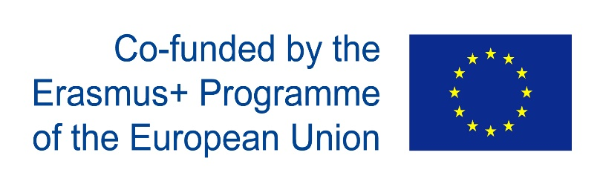

***Project meeting evaluation form***

**Dear Student, we would like to kindly ask you for cooperation with this questionnaire which helps us to evaluate the efficiency of the meeting. Please, answer the following questions:**

|  |  |  |  |  |
| --- | --- | --- | --- | --- |
| ***A. Learning*** | https://encrypted-tbn2.gstatic.com/images?q=tbn:ANd9GcRhU0EfSODbMONJWI1P0QQ5S6q4IPcAgUjYhPqX9nvra3ZWY0i-Nw | https://encrypted-tbn0.gstatic.com/images?q=tbn:ANd9GcRIlmAqOt4EKgOz8A-VcL0BT_piIoxiddRLEKXbhvaz4WocT3FD | https://s-media-cache-ak0.pinimg.com/236x/23/83/b8/2383b8c0a126d1d6e45c69e1f1d8c835.jpg | http://cache2.asset-cache.net/xc/160434188.jpg?v=2&c=IWSAsset&k=2&d=h7Afe17zTSiA5042nz4sKb15ggSYzm5J_7BE6E1sndE1 |
| ***1. I was well prepared for the meeting*** | **□** | **□** | **□** | **x** |
| ***2. I understood the tasks*** | **□** | **□** | **□** | **x** |
| ***3. I participated actively in the learning process*** | **□** | **□** | **□** | **x** |
| ***4. The activities were related to the themes and helped me learn through them*** | **□** | **□** | **□** | **x** |
| ***5. I respected the opinions of the members of the groups*** | **□** | **□** | **x** | **□** |
| ***B. Culture*** | https://encrypted-tbn2.gstatic.com/images?q=tbn:ANd9GcRhU0EfSODbMONJWI1P0QQ5S6q4IPcAgUjYhPqX9nvra3ZWY0i-Nw | https://encrypted-tbn0.gstatic.com/images?q=tbn:ANd9GcRIlmAqOt4EKgOz8A-VcL0BT_piIoxiddRLEKXbhvaz4WocT3FD | https://s-media-cache-ak0.pinimg.com/236x/23/83/b8/2383b8c0a126d1d6e45c69e1f1d8c835.jpg | http://cache2.asset-cache.net/xc/160434188.jpg?v=2&c=IWSAsset&k=2&d=h7Afe17zTSiA5042nz4sKb15ggSYzm5J_7BE6E1sndE1 |
| ***1. I learnt something new about my own country and culture.*** | **□** | **□** | **□** | **x** |
| ***2. I learnt something new about the countries of other partner schools.*** | **□** | **□** | **□** | **x** |
| ***3. I had a chance to share my culture with the students from the partner schools*** | **□** | **□** | **x** | **□** |
| ***4. The visiting students were open to new culture, experience.*** | **□** | **□** | **□** | **x** |
| ***5. The visiting students were polite and overall positive and nice to communicate with.*** | **□** | **□** | **□** | **x** |
| ***6. I made new friends*** | **□** | **□** | **□** | **x** |

1. ***I was surprised by how well they spoke English; how many places we had to visit; that they play the same games as me***

***2. I was confused by nothing***

**3*. During this visit I a lot new things about WW2; young people from other countries, how to dance Belgian Dance***

***4. The most interesting place/places I visited was/Auschwitz; Warsaw Uprising Museum; Schindler’s factory, Film Studio***

***5. The most memorable events/moments of the visit was the trip to Warsaw and visiting the Film Studio and VR show***

***6. I would recommend Erasmus+ programme***

**7. Any other comments Thanks for participation in Erasmus+**