LTTA 1: Short-term joint staff training events of the project War in Films – Different Attitudes and Perspectives“
LEPINGU NUMBER 2019-KA229-80
Tamsalu, Estonia
21−25 November 2019
A meeting of coordinators to exchange of experience and knowledge
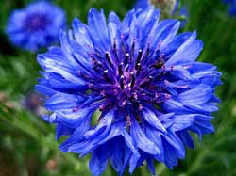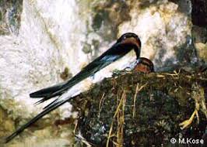
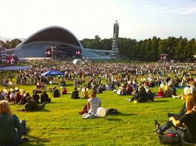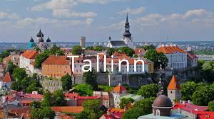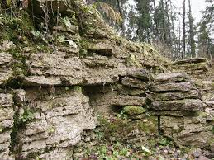

PROGRAMME

WEDNESDAY, 20 November

Arrival in Tallinn
Belgium: 20.11 23.55

ACCOMMODATION:
GO Hotel Shnelli
https://www.gohotels.ee/
Address: Toompuiestee 37/1, 10133 Tallinn
Phone: 631 0102

THURSDAY, 21 November

Arrival in Tallinn
ACCOMMODATION:
GO Hotel Shnelli
https://www.gohotels.ee/
Address: Toompuiestee 37/1, 10133 Tallinn
Phone: 631 0102

Greece: 21.11 13.00
Turkey: 21.11 12.05
Poland: 21.11 12.50

FRIDAY, 22 November
Tamsalu
TIME | ACTIVITY | Remarks
8.13-9.13 | To Tamsalu by train | Ticket: 6.70€
10.00-11.30 | Welcoming meeting  Project presentation, detailed discussion on tasks and activities  Logo voting  Coffee and snacks | - getting acquainted with the school and students
11.30-14.00 | Sightseeing in Tamsalu and Porkuni – WW2  Railway station – deportation  Park – memorials  Vistla  Loksa
14.00-14.30 | Lunch at school
14.30- 17.15 | Planning of the project activities and LTTAs, working on eTwinning, workshop: Europass – workshop: website
17.29  18.00 | To Tapa by train  Dinner in Tapa with the director | Ticket: 1.11€
21.28 | A train to Tallinn | Ticket: 3.91€

SATURDAY, 23 NOVEMBER
Tallinn
Breakfast at the hotel
9.00 Meeting on planning the project:
- working on eTwinning, workshop: Europass - workshop: website
- reflection, evaluation and planning the next LTTA

15.00 Leave for
- Maarjamäe castle and history centre, Pirita tee 56, Ticket: 8€
13.00 - 1.5 hours
- the film museum; Ticket: 8€
17.00 Meal – Maarjamäe restaurant

FREE TIME

19.00 Dinner

SUNDAY, 24 NOVEMBER
Breakfast at the hotel
9.00 Meeting on planning the upcoming project activities and outcomes
- The Museum of Occupations and Freedom: Toompea 8; Ticket: 11 €
- KGB prison cells Pagari 1, (entrance Pikk 59) Ticket: 5€
15.00
Sightseeing - tour with our history teacher
- The Old Town
- Toompea, Alexander Nevski Cathedral, churches
- Telliskivi creative city
19.00 Certification ceremony and farewell dinner - St Patrick’s Pikk 45

MONDAY, 25 November
Departure
Greece: 6.40
Poland: 10.50
Belgium: 12.10
Turkey: 18.05

