- https://www.erasmusdays.eu/?_sfm_event_pays=133&_sft_event_date=11-octobre-2019

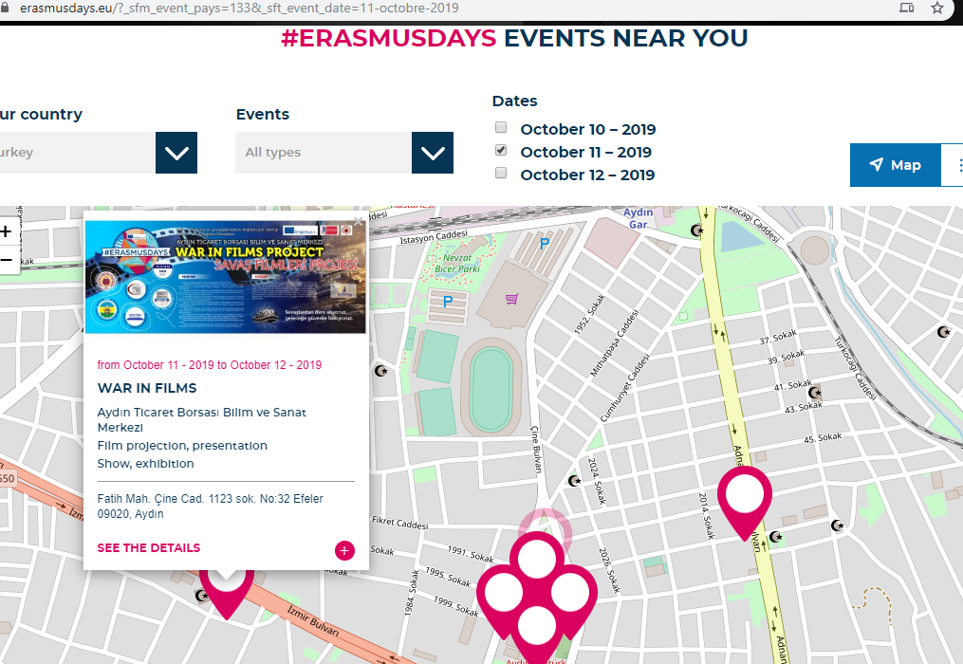

- http://aydintbbilsem.meb.k12.tr/icerikler/okulumuzda-erasmusdays-2019-etkinlikleri-yapildi_7873789.html

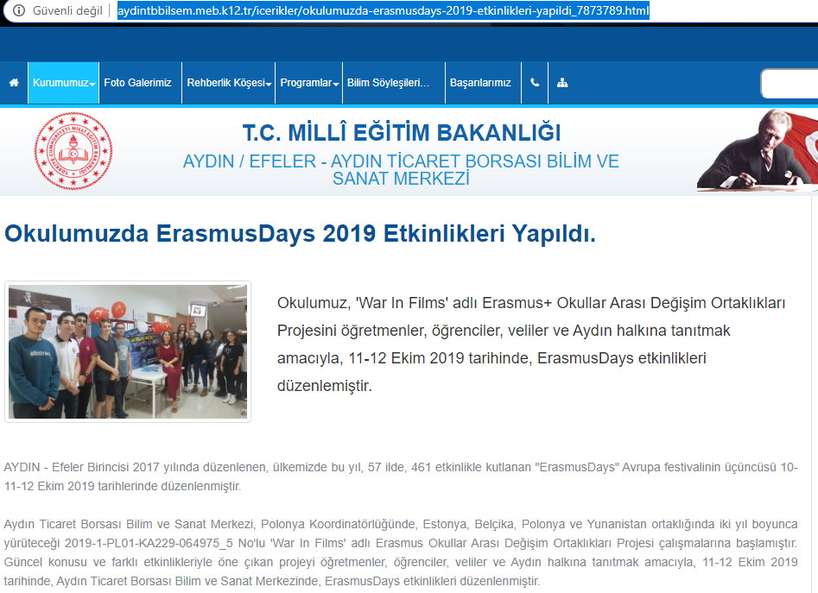

- https://www.timeturk.com/aydin-bilsem-de-erasmus-days-etkinligi-duzenlendi/haber-1247226
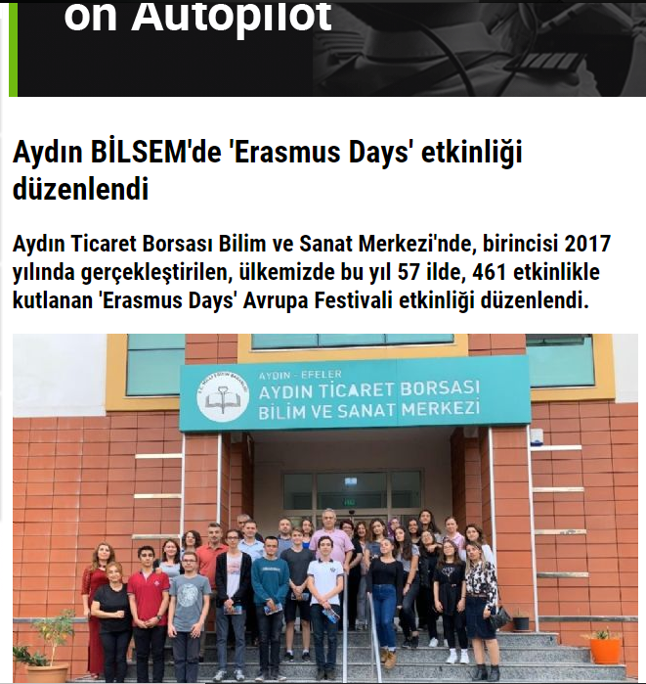

- http://www.merhabahaber.com/aydin-bilsemde-erasmus-days-etkinligi-duzenlendi-1788217h.htm

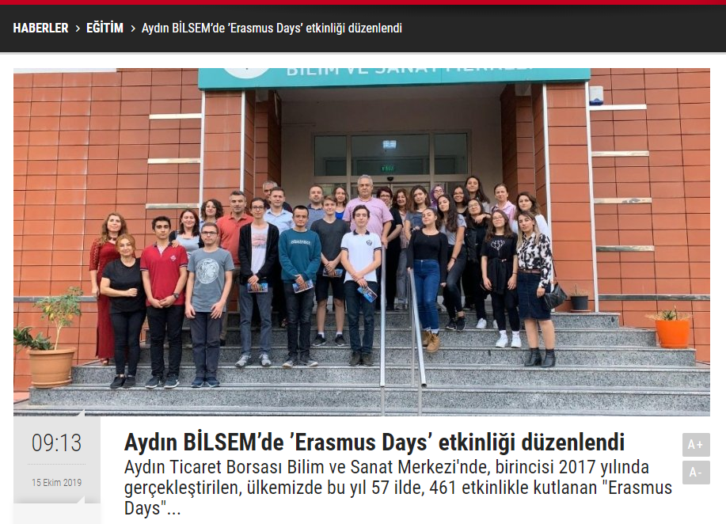

- https://www.iha.com.tr/aydin-haberleri/aydin-bilsemde-erasmus-days-etkinligi-duzenlendi-2425508/
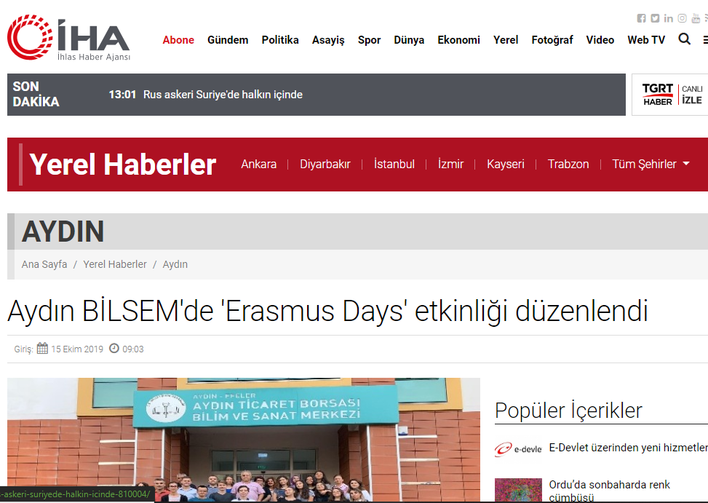

- https://www.haberturk.com/aydin-haberleri/72617146-aydin-bilsemde-erasmus-days-etkinligi-duzenlendi
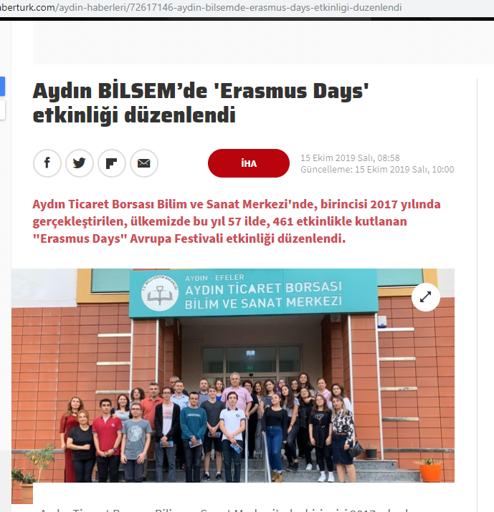

- http://beta.eba.gov.tr/haber/1571046725
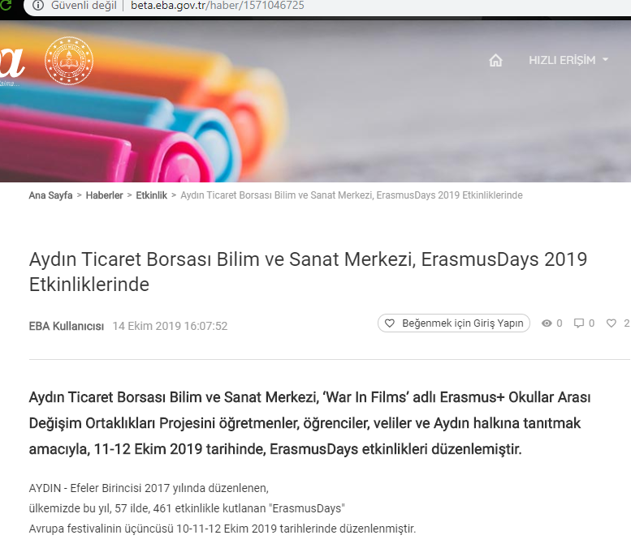
- https://tr-tr.facebook.com/aydinbilsem/
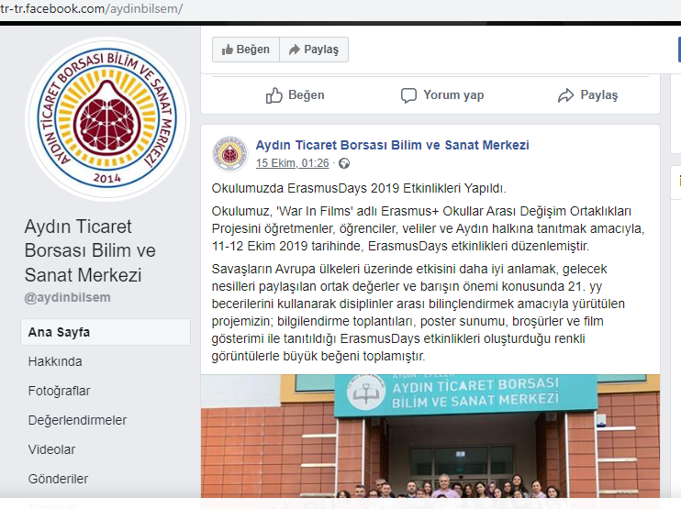
- https://www.iha.com.tr/aydin-haberleri/aydin-bilsemin-erasmus-projesi-hareketliligi-basladi-aydin-2470027/

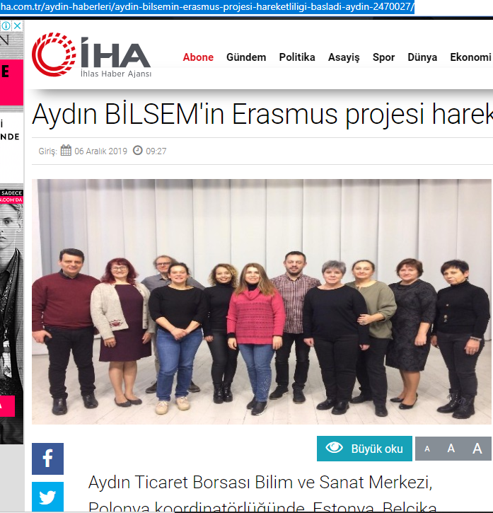

- https://www.nazilliadalet.com/haber/3407859/aydin-bilsemin-erasmus-projesi-hareketliligi-basladi
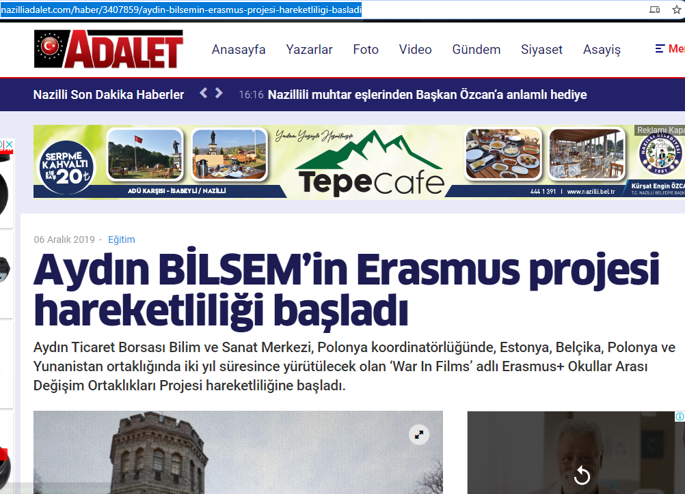

- https://www.karar.com/aydin/aydin-bilsemin-erasmus-projesi-hareketliligi-basladi-1405820
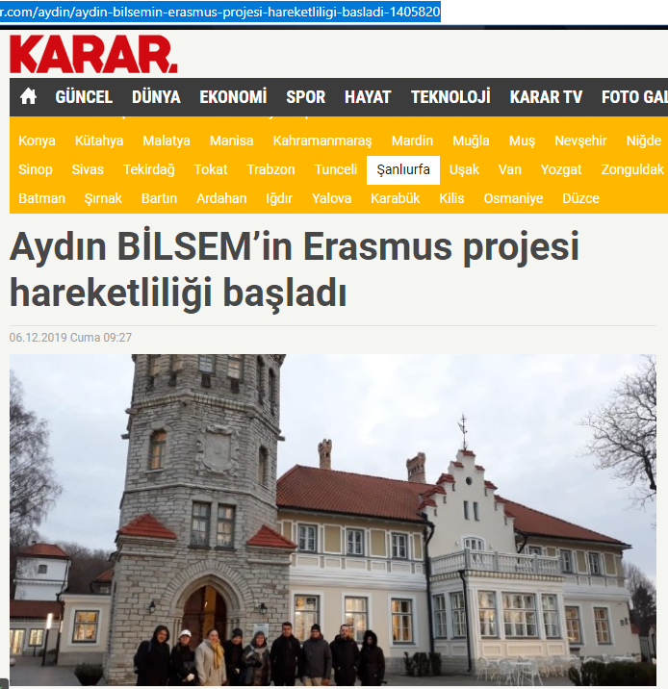
- http://aydintbbilsem.meb.k12.tr/icerikler/okulumuzun-erasmus-ka229-war-in-films-projesi-kapsaminda-polonya-hareketliligi_9216783.html

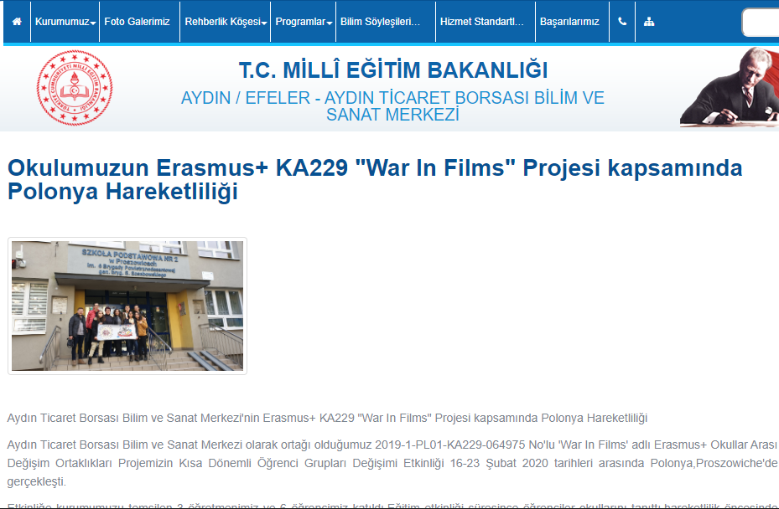

*News on press about second LTT in Poland

- https://www.timeturk.com/aydin-bilsem-polonya-da-okullarini-tanitti/haber-1371403
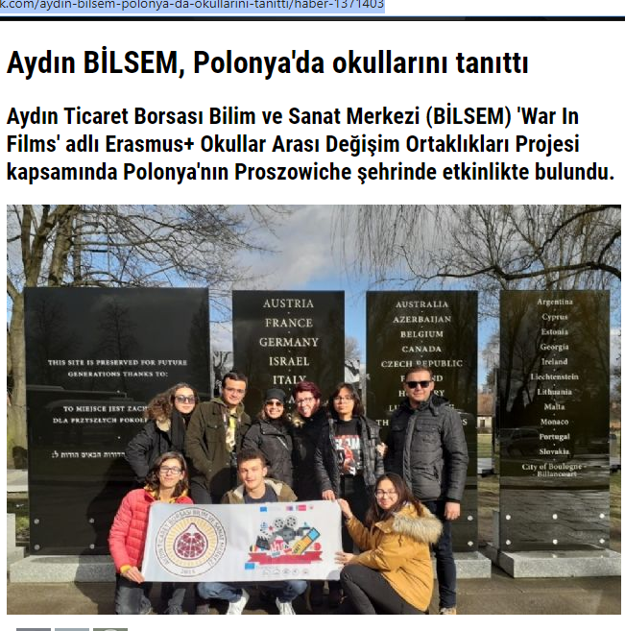

- https://www.haberturk.com/aydin-haberleri/76010344-aydin-bilsem-polonyada-okullarini-tanitti

